**TASK1**

**DROP DATABASE IF EXISTS `TASK1`;**

**CREATE DATABASE `TASK1`;**

**USE `TASK1`;**

**CREATE TABLE EMPLOYEE(**

**Fname VARCHAR(15) NOT NULL,**

**Minit CHAR,**

**Lname VARCHAR(15) NOT NULL,**

**Ssn CHAR(9) NOT NULL,**

**Bdate DATE,**

**Address VARCHAR(30),**

**Sex CHAR,**

**Salary DECIMAL(10,2),**

**Super_ssn CHAR(9) NOT NULL,**

**Dno INT,**

**PRIMARY KEY (Ssn)**

**);**

**INSERT INTO `EMPLOYEE` VALUES ('john','B','Smith','123456789','1965-01-09','731 Fondren,Houstan,TX','M',30000,'333445555',5);**

**INSERT INTO `EMPLOYEE` VALUES ('Franklin','T','wong','333445555','1955-12-08','638 voss,Houstan,TX','M',40000,'888665555',5);**

**INSERT INTO `EMPLOYEE` VALUES ('Jennifer','J','zelya','999887777','1968-01-19','3321 castle,spring,TX','F',25000,'987654321',4);**

**INSERT INTO `EMPLOYEE` VALUES ('Alicia','S','wallace','987654321','1941-06-20','291 berry, bellaire,TX','F',43000,'888665555',4);**

**INSERT INTO `EMPLOYEE` VALUES ('Ramesh','K','narayan','456789123','1962-09-19','975 fire oak,humble,TX','M',38000,'333445555',5);**

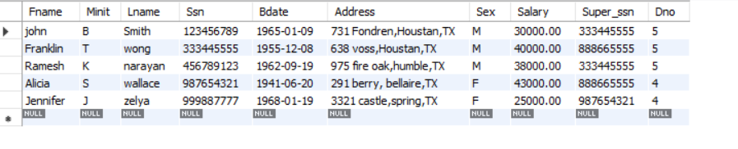

**CREATE TABLE DEPARTMENT(**

**Dname varchar(15) NOT NULL,**

**Dnumber int not null,**

**Mgr_ssn char(9) not null,**

**Mgr_start_date date,**

**PRIMARY KEY (Dnumber),**

**UNIQUE (Dname),**

**FOREIGN KEY (Mgr_ssn) REFERENCES EMPLOYEE(Ssn)**

**);**

**INSERT INTO `DEPARTMENT` VALUES ('Research',5,'333445555','1988-05-22');**

**INSERT INTO `DEPARTMENT` VALUES ('Aministration',4,'987654321','1995-01-01');**

**INSERT INTO `DEPARTMENT` VALUES ('Headquarters',1,'888665555','1981-06-19'); -- give error**

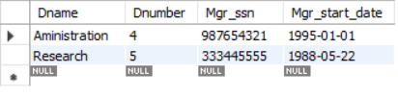

**CREATE TABLE DEPT_LOCATIONS(**

**Dnumber int not null,**

**Dlocation varchar(15) not null,**

**PRIMARY KEY (Dnumber, Dlocation),**

**FOREIGN KEY (Dnumber) REFERENCES DEPARTMENT(Dnumber)**

**);**

**INSERT INTO `DEPT_LOCATIONS` VALUES (1,'Houstan'); -- give error**

**INSERT INTO `DEPT_LOCATIONS` VALUES (4,'stafford'); -- give error**

**INSERT INTO `DEPT_LOCATIONS` VALUES (5,'bellaire'); -- give error**

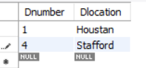

**CREATE TABLE PROJECT(**

**Pname varchar(15) not null,**

**Pnumber int not null,**

**Plocation varchar(15),**

**Dnum int not null,**

**PRIMARY KEY (Pnumber),**

**UNIQUE (Pname),**

**FOREIGN KEY (Dnum) REFERENCES DEPARTMENT(Dnumber)**

**);**

**INSERT INTO `PROJECT` VALUES ('productX',1,'bellaire',5);**

**INSERT INTO `PROJECT` VALUES ('productY',2,'Sugarland',5);**

**INSERT INTO `PROJECT` VALUES ('productZ',3,'houstan',5);**

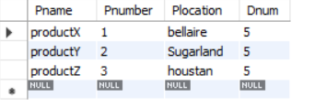

**CREATE TABLE WORKS_ON(**

**Essn char(9) not null,**

**Pno int not null,**

**Hours DECIMAL(3,1) not null,**

**PRIMARY KEY (Essn, Pno),**

**FOREIGN KEY (Essn) REFERENCES EMPLOYEE(Ssn),**

**FOREIGN KEY (Pno) REFERENCES PROJECT(Pnumber)**

**);**

**INSERT INTO `WORKS_ON` VALUES ('123456789',1,32.5);**

**INSERT INTO `WORKS_ON` VALUES ('123456789',2,7.5);**

**INSERT INTO `WORKS_ON` VALUES ('666885555',3,40.0);**

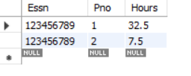

**CREATE TABLE DEPENDENT(**

**Essn char(9) not null,**

**Dependent_name varchar(15) not null,**

**Sex char,**

**Bdate date,**

**Relationship varchar(8),**

**PRIMARY KEY (Essn, Dependent_name),**

**FOREIGN KEY (Essn) REFERENCES EMPLOYEE(Ssn)**

**);**

**INSERT INTO `Dependent` VALUES ('333445555','ALice','F','1986-04-05','Daughter');**

**INSERT INTO `Dependent` VALUES ('333445555','Theodore','M','1983-10-25','Son');**

**INSERT INTO `Dependent` VALUES ('333445555','joy','F','1958-05-03','spouse');**

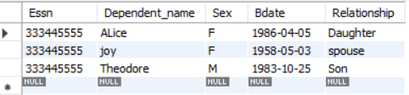

**TASK2**

**drop database if exists `task2`;**

**create database`task2`;**

**use `task2`;**

**create table airport(**

**`airport_code` varchar(15) not null,**

**`name` varchar(15) not null,**

**`city` varchar(20) not null,**

**`state` varchar(20) not null,**

**primary key(airport_code)**

**);**

**insert into`airport` values();**

**create table flight(**

**`flight_number` varchar(25) not null,**

**`airline` varchar(15) not null,**

**`weekdays` varchar(20) not null,**

**primary key(flight_number)**

**);**

**insert into`flight_number` values();**

**create table flight_leg(**

**`leg_number` varchar(25) not null,**

**`departure_airport_code` varchar(30) not null,**

**`scheduled_departure_time` int not null,**

**`arrival_airport_code` varchar(30) not null,**

**`scheduled_arrival_time` int not null,**

**primary key(flight_number,leg_number),**

**foreign key(fight_number)references flight(flight_number)**

**);**

**insert into`flight_leg` values();**

**create table leg_instance(**

**`date` date not null,**

**`number_of_available_seats` int not null,**

**`airplane_id` varchar(15) not null,**

**`departure_airport_code` varchar(20) not null,**

**`departure_time` double(2,2) not null,**

**`arrival_airport_code` varchar(20) not null,**

**`arrival_time` int not null,**

**primary key(flight_number,leg_number,date),**

**foreign key(flight_number)references flight(flight_number),**

**foreign key(leg_number)references flight_leg(leg_number)**

**);**

**insert into`leg_instance` values();**

**create table fare(**

**`fare_code` int(20)not null,**

**`amount` int not null,**

**`restrictions` varchar(25),**

**primary key(flight_number,fare_code),**

**foreign key(flight_number)references flight(flight_number)**

**);**

**insert into`fare` values();**

**create table airplane_type(**

**`airplane_type_name` varchar(20)not null,**

**`max_seats` int not null,**

**`company` varchar(20) not null,**

**primary key(airplane_type_name)**

**);**

**create table can_land(**

**`airport_code` varchar(15) not null,**

**primary key(airplane_type_name,airport_code),**

**foreign key(airplane_type_name)references airplane_type(airplane_type_name),**

**foreign key(airport_code)references airport(airport_code)**

**);**

**create table airplane(**

**`airplane_id` int not null,**

**`total_number_of_seats` int not null,**

**`airplane_type` varchar(20) not null,**

**primary key(airplane_id),**

**foreign key(airplane_id)references leg_instance(airplane_id)**

**);**

**create table seat_reservation(**

**`date` date not null,**

**`seat_number` int not null,**

**`customer_name` varchar(20),**

**`customer_phone` int not null,**

**primary key(flight_number,leg_number,date,seat_number),**

**foreign key(flight_number)references flight(flight_number),**

**foreign key(leg_number)references flight_leg(leg_number),**

**foreign key(date)references leg_instance(date)**

**);**